Building Stronger Communities Through Meaningful Social Value

By Danielle Doherty, Head of Social Value, VINCI Building

Thank you to everyone who joined the Pagabo Live webinar. It was great to be part of such an engaging discussion and encouraging to see so many organisations prioritising the long-term social, economic and educational impact of the projects we deliver.
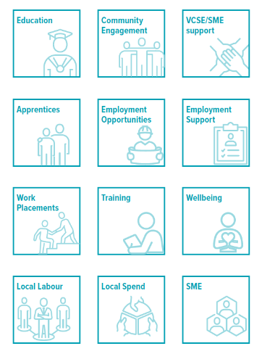
At VINCI Building, social value isn’t an add-on, it’s central to how we build, operate and collaborate. Through our social value approach, we measure impact across 12 organisational KPIs, giving us a transparent, consistent framework that drives real, lasting benefits for the communities we work with. This includes supporting local employment and apprenticeships, strengthening education pathways and widening access to meaningful opportunities.
Over the past year, our teams have increased community impact across projects by delivering more education engagements, deepening partnerships with local organisations and continually improving how we monitor and measure outcomes.
Measuring and Demonstrating Real Social Value
We collect both quantitative and qualitative data, from apprentice weeks, training hours and employment outcomes to case studies, partner feedback and local economic impact. All data is validated through our digital platform and project reporting to ensure accuracy and accountability.
Contractual Expectations and Flexibility
We’re seeing more clients look for clearer ways to monitor and support the delivery of social value. While clearer expectations can be positive, social value must remain flexible and co-created with communities. Overly punitive approaches risk driving box-ticking rather than meaningful change, so we continue to advocate for shared responsibility and collaborative delivery.
What Radical Social Value Means to Us
For us, radical social value means shifting the system:
- co-designing with communities
- focusing on long-term change over short-term outputs
- addressing inequalities
- strengthening education and skills pathways
- ensuring every project leaves a legacy that lasts far beyond completion

